**CSV Plotting**

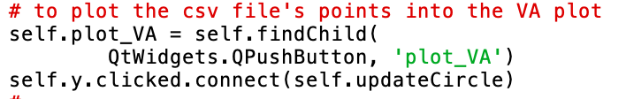

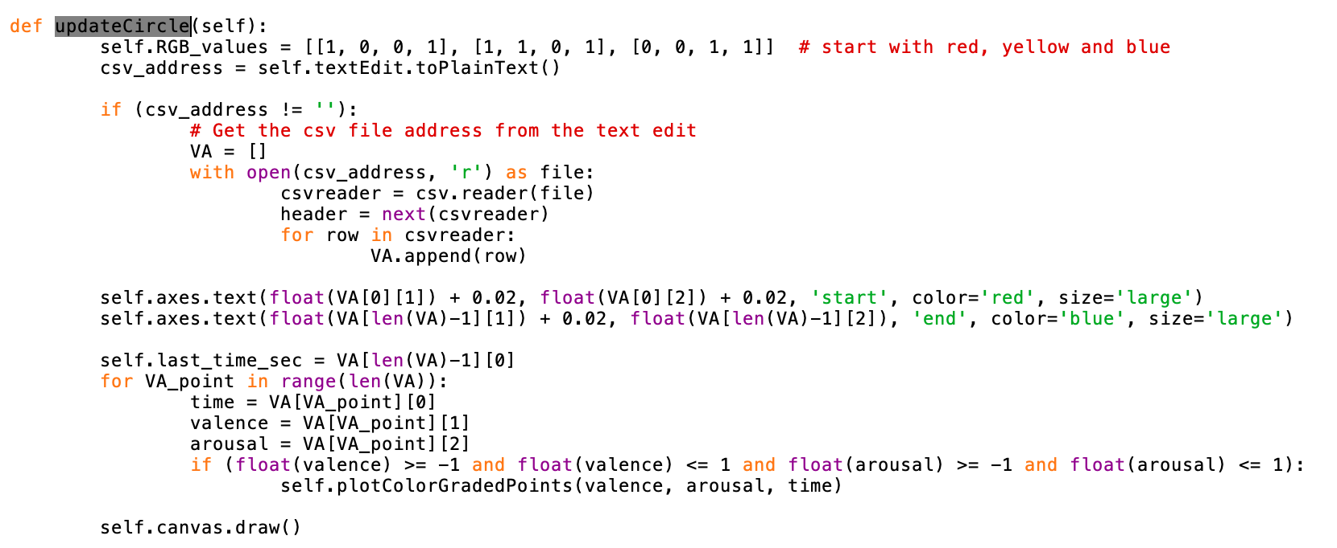

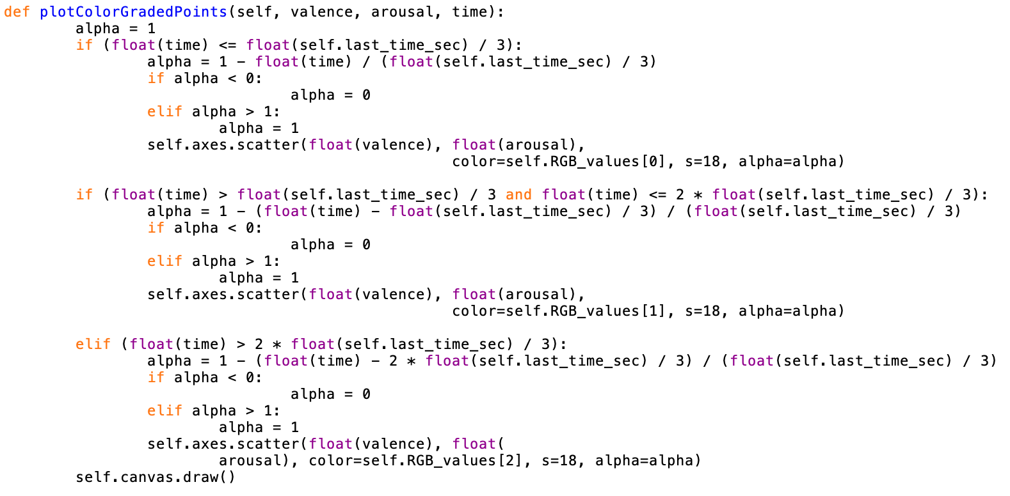

* Checks to see if the CSV file entry is empty or not
* Make an array to save data read from the file
* Open the CSV file as a read file
* Extract data from the csv file row by row and put them in the array created (data gets saved in a 3-row format)
* Row 1 - time
* Row 2 - valence
* Row 3 - arousal
* Go through the array, extract individual time, valence and arousal values, and update these on the plot using the plotColorGradedPoints function.

**WAV Plotting**

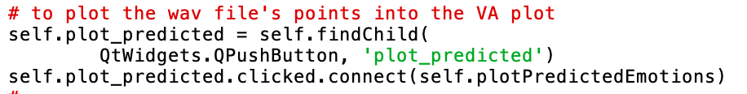

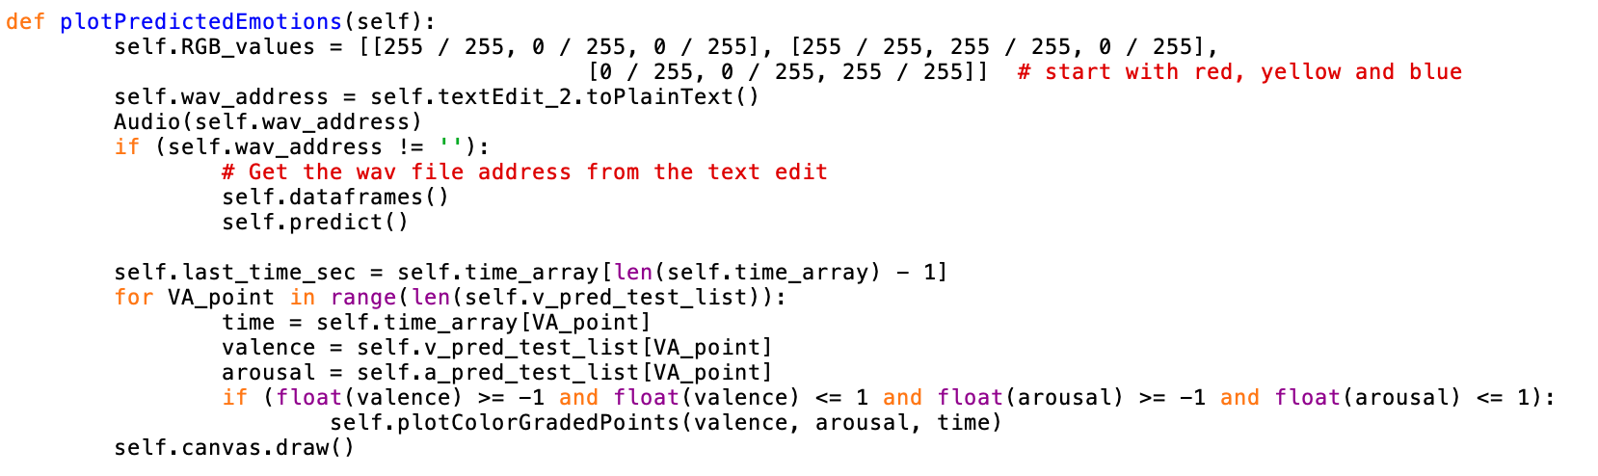

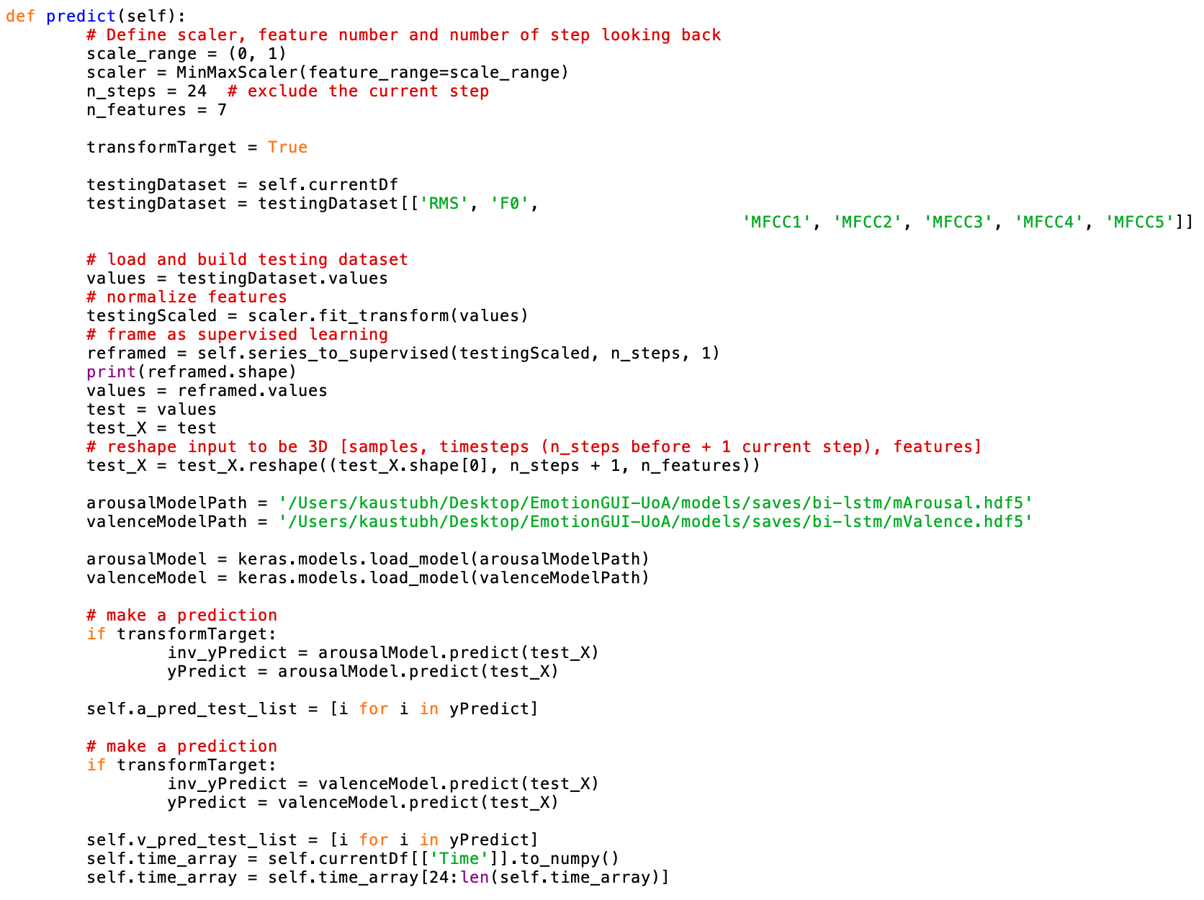

**Manual Plotting**

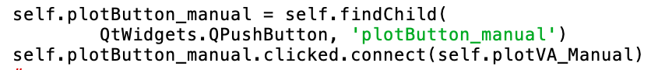

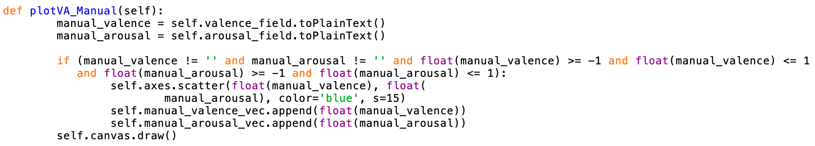

* Extract values from the manual valence and arousal fields and convert them into text.
* If both extracted values are not empty and within the specified range, plot the values using the inbuilt draw function.\

Questions -

What is this 0.2? (updateCircle)



How does this work? (updateCircle)



Why the division of 3 here? (PlotColourGradedPoints)

